RAS Application Suite: Phase 2 Summary
This document provides a summary of the development activities for Phase 2 of the RAS development process. The document also outlines any changes to the previous project documentation as well as any new challenges that have arisen.

Milestones
The goal for Phase 2, as outlined by the Project Plan document, is to get the site template set up and to provide the application users with a mechanism for registering with our membership system. The plan outlined the following tasks for completion:
- Create the site template.
- Create the registration form.
- Create the script to process the registration.
- Create the form to activate registrations.
- Create the script to activate registrations.
- Configure an SMTP server for sending emails for registration confirmation.
- Create a member log in form.
- Create the script for processing member logins.

Item 1 Status – Site Template
As laid out in the Phase 1 summary, the site template task was put off until Phase 2 of the project. The site template was chosen and has been completed.
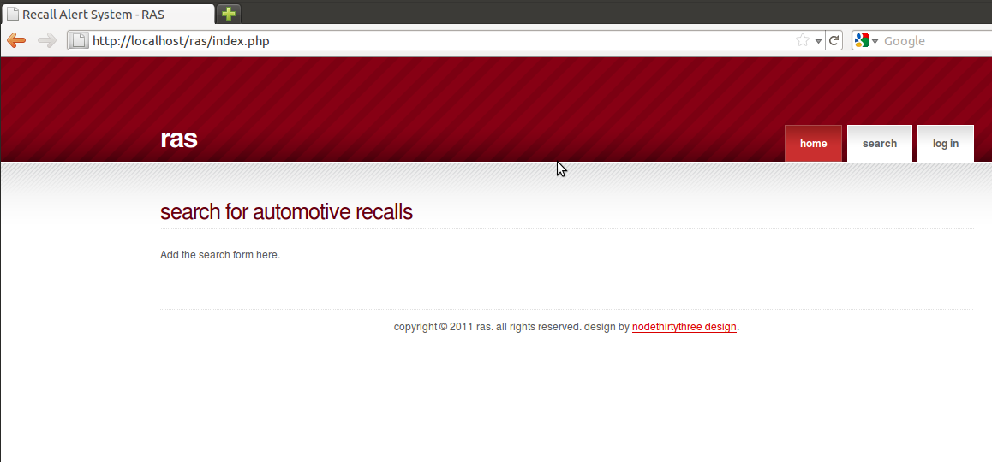
Figure 1-1: Screen shot of site home page

Item 2 Status – Create the registration form
In order to allow users to use the notifications system they must register as members of the site. This task was to create the UI for users to register with the site. The following fields and attributes were required for completion:
- Name – required, no more than 256 characters
- Email – required, must be email address, no more than 256 characters
- Password – required, no more than 256 characters
- Confirm Password – not required, must match Password field
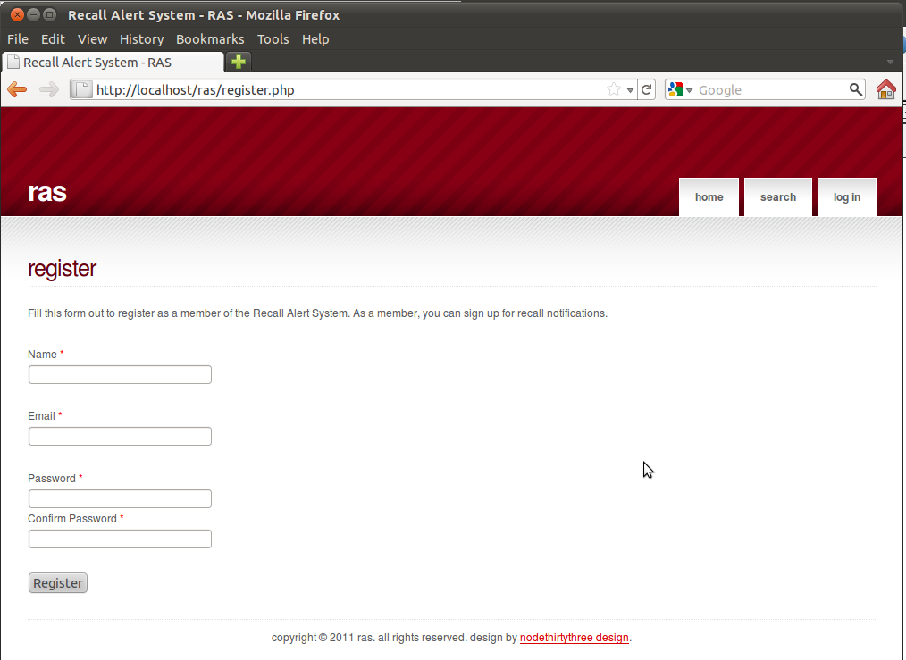
Figure 1-2: Registration form screen shot
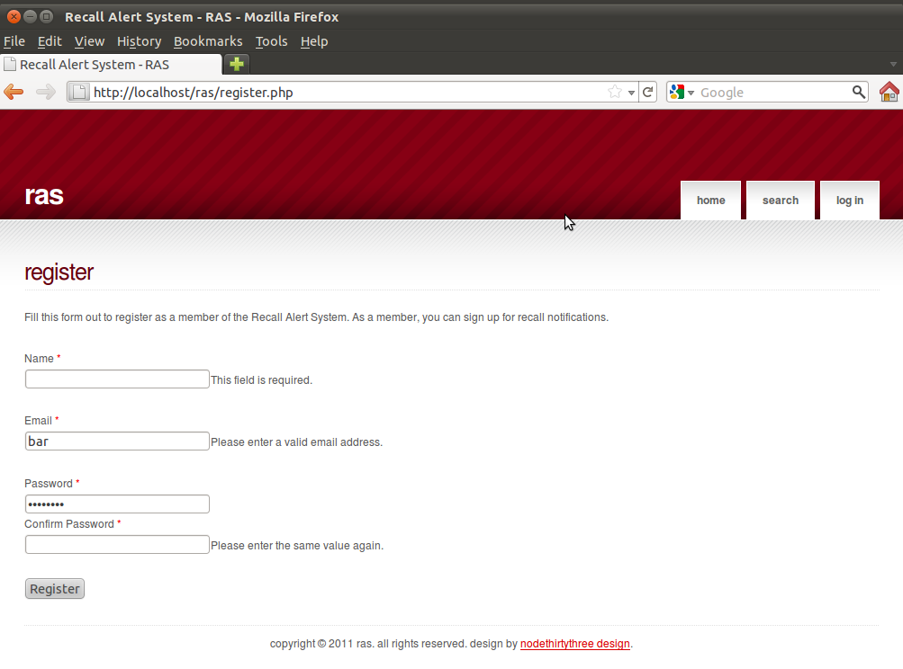
Figure 1-3: Screen capture of the required fields.

Item 3 Status – Process Registration
The goal for this task was to create the controller script for handling the request to create memberships. Due to the amount of effort in setting up the plumbing for building site forms and the site template, this task has been moved to Phase 3. (See Devlierables chart in the Document Changes section)

Item 4 Status – Membership Activation Form
This page should contain a form to allow members to enter the information sent to them via email from the process registration script. The form should have the following form fields.
- Token – required, maximum of 256 characters
- Password – required – the member password used during registration
- Confirm password – must match Password
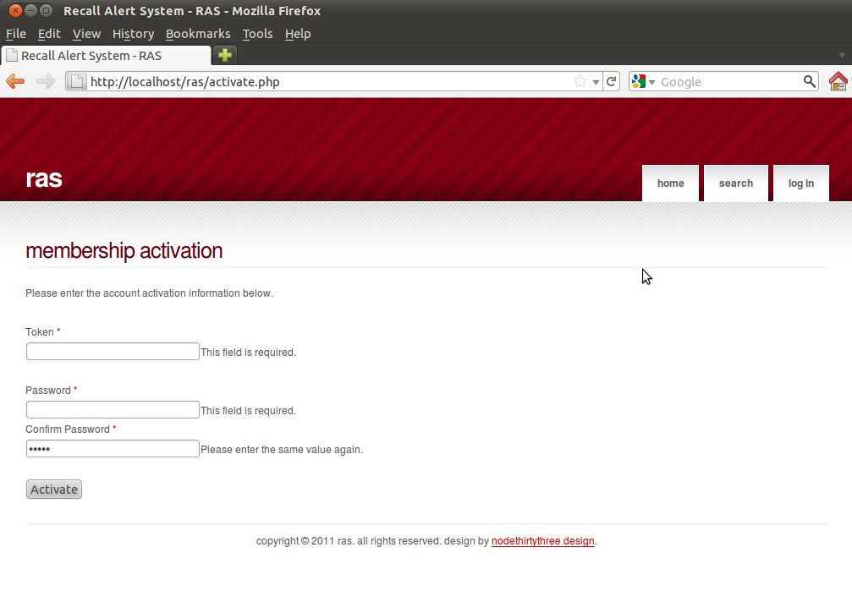
Figure 1-4: Membership activation form with field requirements

Item 5 Status – Membership Activation Script
The task here was to create the controller script for processing the membership activation form input. Due to the amount of effort in setting up the plumbing for building site forms and the site template, this task has been moved to Phase 3. (See Devlierables chart in the Document Changes section)

Item 6 Status – Configuring the SMTP Server
An email server is needed to facilitate the membership activation. The task here is to identify the appropriate server for sending email to the members and configure it for use with the application. This includes setting up the site scripts for communicating with the server.

Due to the amount of effort in setting up the plumbing for building site forms and the site template, this task has been moved to Phase 3. (See Devlierables chart in the Document Changes section)

Item 7 Status – Member Login form
A login form is needed to allow users to register for notifications. The form for authenticating users should have the following form fields.
- User Name – required (this is the user's email address).
- Password – required
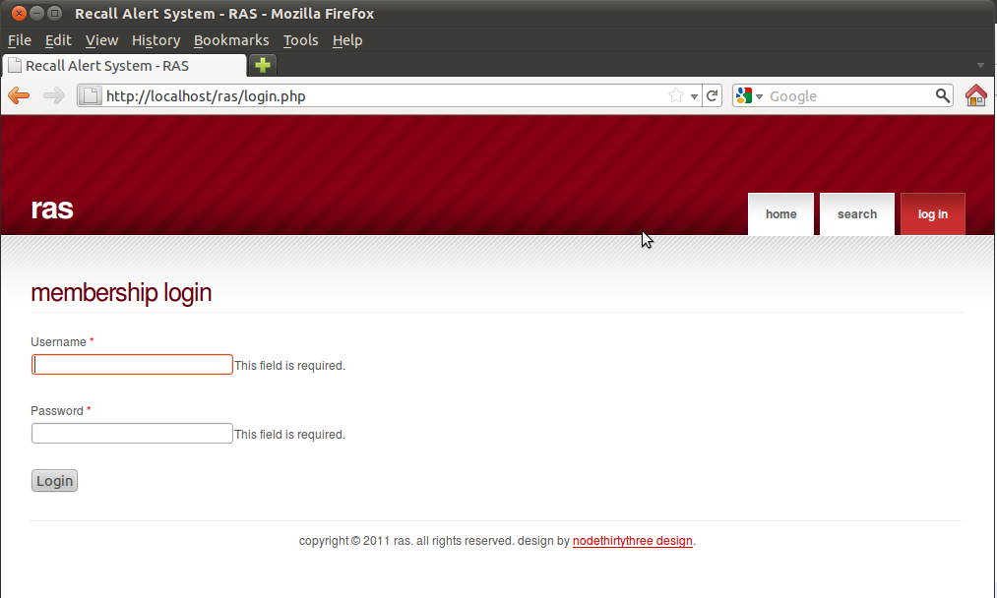
Figure 1-5: Member login screen with required field messages.

Item 8 Status – Member login script
The goal for this task was to create the controller script for handling the request to login to the member section. Due to the amount of effort in setting up the plumbing for building site forms and the site template, this task has been moved to Phase 3. (See Devlierables chart in the Document Changes section)

Document Changes/Schedule Changes
We have adjusted the Project Plan's deliverables to reflect the move of the membership scripting to Phase 3. The updated chart is displayed below. It should be noted that pushing the scripting to Phase 3 may have an impact on the schedule for Phase 3 items.

Deliverable | Date
Project Plan | 6/19
Meeting Notes | 6/20
System & Software Specification | 6/26
Meeting Notes | 6/27
Test Plan & User Guide | 7/3
Meeting Notes | 7/4
Design | 7/10
Meeting Notes | 7/11
Hosted Website (Phase 1)  Provide a hosted webpage with the ability to search for automotive recall data. | 7/17
Meeting Notes | 7/18
Membership Feature (Phase 2)  Complete website template. Enhance the website by adding a membership feature. | 7/24
Meeting Notes | 7/25
Food Recalls (Phase 3)  Complete membership control scripting. Configure SMTP server. Enhance the website by adding the ability to search for food recall data. | 7/31
Meeting Notes | 8/1
Consumer Goods Recalls (Phase 4)  Enhance the website by adding the ability to search for consumer goods recall data. | 8/7
Meeting Notes | 8/8
Touch-ups (Phase 5)  Include any bug fixes, touch-ups, and any other enhancements agreed upon. | 8/14
Meeting Notes | 8/15
Final Report | 8/21
Table 1-1: Updated Project Deliverables

Retrospective
Due to the perceived simplicity of the RAS system, the developers decided to forgo bringing in an MVC framework such as CakePHP or Symfony. The downside to this decision was realized in Phase 2 when unforeseen development was needed to facilitate common form building tasks. This forced the team to shift away from working on the scripting that would have provided more visible functionality to focus on plumbing tasks.

Additionally, it would have been prudent for the development team to spend some time researching available Open-source alternatives instead of reinventing the wheel for form building. This lesson will be kept in mind for future phases.

